EXPERIMENT 4

NAME: GAYATHRI JAYAM S ROLLNO: 240701142
Create a prototype with familiar and unfamiliar navigation elements. Evaluate ease of use with different user groups using proto.io
Screen 1:
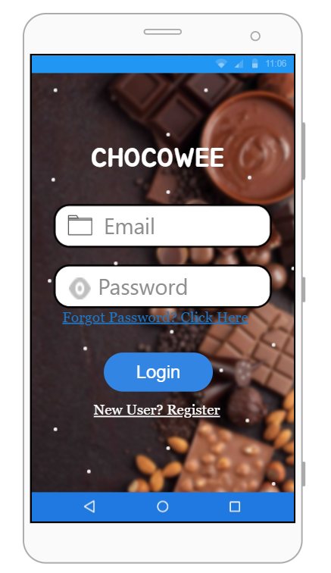
Familiar Icons/UI Elements:
- Email Field: Standard input field for username/email
- Password Field: Standard password input with hidden characters
- Login Button: Common call-to-action button
- "Forgot Password?" Link: Standard password recovery option
- "New User? Register" Link: Common new account creation option
Possibly Unfamiliar Elements:
- Simple Text-Based Interface: No social media login options (Google/Facebook) which users might expect
- No "Remember Me" Checkbox: Users may expect this for convenience
- No Visual Branding Elements: Logo or brand image could improve recognition

Screen 2: Chocolate Listing Page
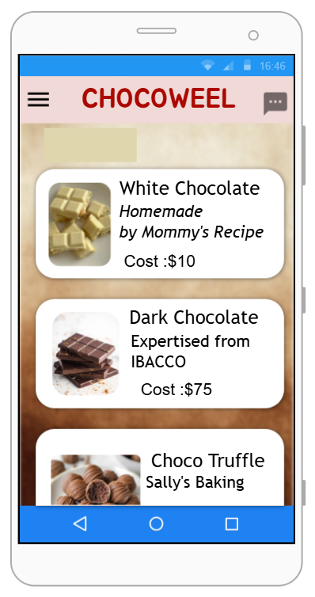
Familiar Icons/UI Elements:
- Product Cards: Image + name + description + price layout (standard e-commerce pattern)
- Product Images: White Chocolate and Dark Chocolate visuals
- Price Display: $10and$75 clearly shown
- Product Descriptions: "Homemade by Mommy's Recipe", "Expertised from IBACCO"
Possibly Unfamiliar Elements:
- No "Add to Cart" Button on Listing Page: Users may expect quick add option without opening details
- No Search or Filter Option: Users cannot sort by price, type, or rating
- No Rating Stars Displayed on listing page
Card Click Behavior Unclear: Users might not know if clicking image or text opens details
Screen 3: Product Details Page (Sally's Bakery)
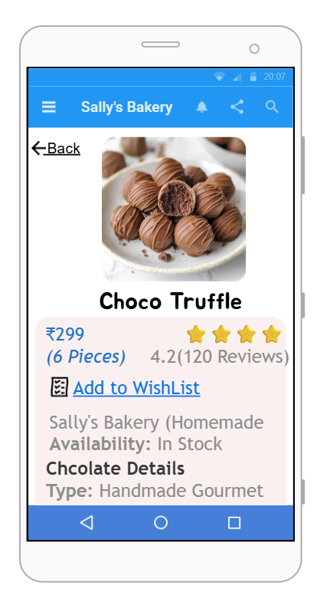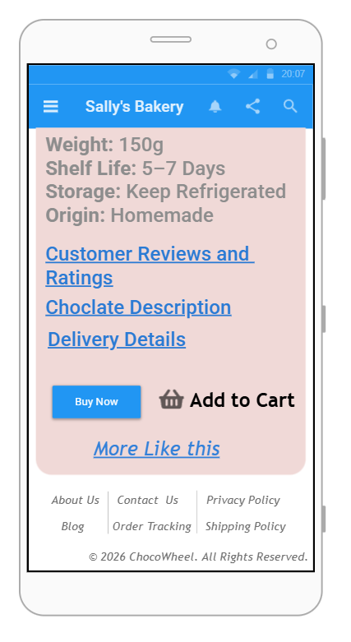
Familiar Icons/UI Elements:
- Product Brand Name: Sally's Bakery clearly displayed
- Availability Status: "In Stock" shown
- Chocolate Details: Type (Handmade Gourmet)
- Product Specifications: Weight (150g), Shelf Life (5–7 days), Storage (Keep Refrigerated), Origin (Homemade)
- Customer Reviews and Ratings Section
- Chocolate Description Section
- Delivery Details Section
- "Buy Now" and "Add to Cart" Buttons
- "More Like This" Recommendations
Possibly Unfamiliar Elements:
- Reviews and Ratings - No interactive stars or written reviews visible
- "More Like This" - No actual clickable product thumbnails shown

Screen 4: Payment Gateway Page
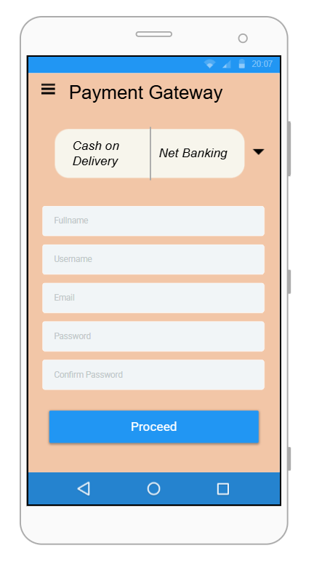
Familiar Icons/UI Elements:
- Payment Options: Cash on Delivery, Net Banking (standard payment methods)
- Clear Option Selection: Radio buttons or checkboxes expected
Possibly Unfamiliar Elements:
- No Card Payment Option: Credit/Debit card, UPI, or digital wallets missing
- No Order Summary: Total amount, item list, or delivery charges not shown
- No "Confirm Payment" Button explicitly labeled
- No Back or Edit Cart Option from payment screen

Screen 5: Payment Successful / Order Confirmation Page
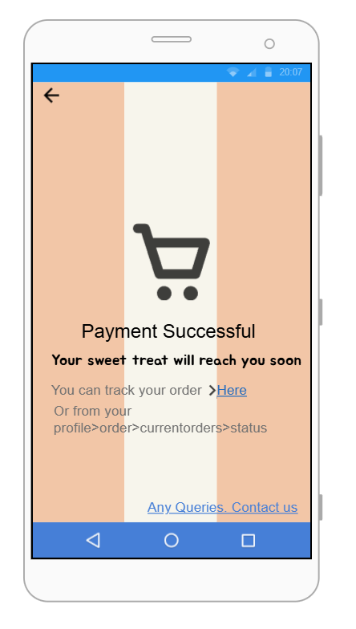
Familiar Icons/UI Elements:
- Success Message: "Payment Successful"
- Confirmation Text: "Your sweet treat will reach you soon"
- Order Tracking Link: "You can track your order > Here"
- Alternative Tracking Path: "profiles > order > current orders > status"
- Contact Option: "Any Queries, Contact us"
- Footer Navigation: About Us, Contact Us, Privacy Policy, Blog, Order Tracking, Shipping Policy
- Copyright Notice: © 2024 ChocoMawer. All Rights Reserved.
Possibly Unfamiliar Elements:
- No Order Number/ID Displayed for reference
- No Estimated Delivery Date shown clearly
- No "Share Order" or "Download Receipt" Option
- No "Continue Shopping" Button - users must use footer navigation
- Tracking Link Format - Text-based rather than a prominent button

Prototype Link :
https://harshavarthinia.proto.io/player/index.cfm?id=94f30e58-e759-4642-87ad-45f56eca805a

